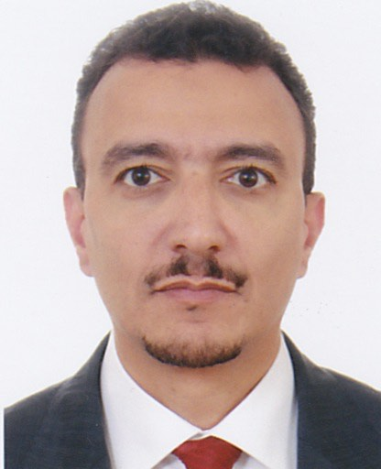

Wael Mansour is a Customer Consultant for Research Management Solutions for Turkey Middle East & Central Asia at **Elsevier**

Wael has a Bachelor degree in Library and Information science from Cairo University and an MBA with focus on IT Management from University of Leicester.

He has been in the Education Technology field for more than 14 years, with overall 20 years of experience.

Wael has participated in many conferences in the region including the Gulf SLA, he has managed many roles including: Training, Pre Sales, Business Development and Managing a Sales Team for the Middle East region with many companies including Elsevier, DuPont in addition to representing companies like Blackboard, Question Mark & VTLS.

Wael has been in the Education Technology field for more than 14 years, with overall 20 years of experience. Wael has participated in many conferences in the region including the Gulf SLA, he has managed many roles including: Training, Pre Sales, Business Development and Managing a Sales Team for the Middle East region with many companies including Elsevier, DuPont in addition to representing companies like Blackboard, Question Mark & VTLS.